**Using Event Viewer**

**Time Required:** Approximately 15 minutes

**Objective:** Use Event Viewer to view system log events.

**Description:** In this activity, you use Event Viewer to examine system log events, and you practice using a filter.

1. Open **Server Manager**, if it is not open.
2. Click **Tools** and click **Event Viewer**.
3. In Event Viewer, click the **right-pointing arrow** in front of Windows Logs (under Event Viewer (Local).

* What logs do you see?

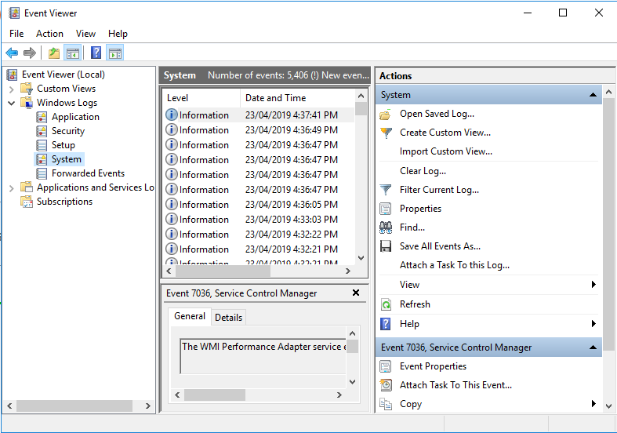

1. Click each log to view the information displayed for it in the middle pane.
2. Click the **right-pointing arrow** in front of **Custom View** in the left pane.
3. Click **Administrative Events** under Custom View in the left pane. The middle pane shows a compilation of errors and warnings from all administrative logs. Administrative Events is a default filter created for viewing important events and can be a good place to start looking for a problem.
4. Click **System** in the left pane to view the system log contents. In the middle pane, briefly scroll through the listed events.

* Are any errors or warnings reported? If so, find out more about one or two of the errors or warnings by clicking them and viewing the details.

1. Click the **right-pointing arrow** in front of **Applications and Services Logs** in the left pane. Click each log to view its contents in the middle pane and click on one or two events for each log.
2. Click the **View** menu at the top of the window and click Show Analytic and Debug Logs, there is no check mark already in front of this selection.
3. Right-click **System** under Windows Logs in the tree and click **Properties**.

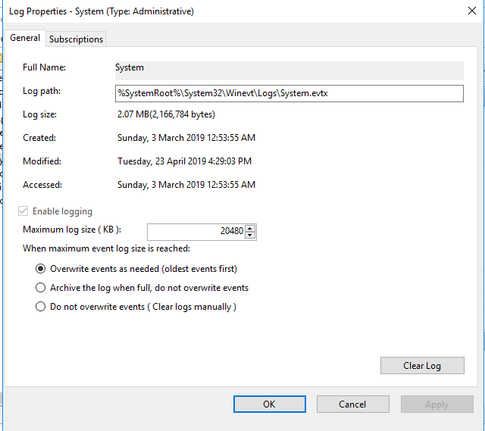

1. In the Log Properties—System (Type: Administrative) dialog box, the default selection for managing the system log is to Overwrite events as needed (oldest events first). Click **Archive the log when full, do not overwrite events**, This option enables you to keep historic log information, but you will need to periodically delete archived logs you do not need. Notice the location of the system log as shown in the Log path box. This is useful information so that you know where to maintain the logs.
2. Change the **Maximum log size (KB)** to **22016**.
3. Click **OK** in the Log Properties—System (Type: Administrative) dialog box.
4. Click **System** under Windows Logs in the tree, if it is not already selected.
5. In the right pane, click **Filter Current Log**.
6. Click the **down arrow** for **Event sources** to view the options you can use for filtering, If you were to select one or more of these options, only events for these sources would be displayed in the system log (but the events for other sources would still be tracked and saved so you could change the filter to view them later). Click the pointer in a blank area of the dialog box to close the listing.
7. Click the **down arrow** for **Keywords** and notice the keywords you can use to build a filter (events containing the keywords you select would be displayed). Click the pointer in a blank area of the dialog box to close the listing of keywords.
8. Assume that you only want to view the error messages in the system log. Click the box for **Error**, as shown.

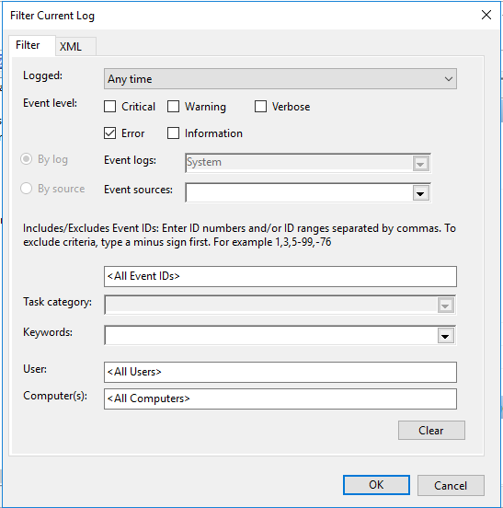

1. Click **OK** in the Filter Current Log dialog box.

* How does using the filter change what you view in the system log? Does this mean that the events you viewed before creating the filter are deleted, or simply not displayed?

1. Close Event Viewer.